Dear Families,

I’m writing to share exciting news: we’ll be using a website called NoRedInk.com in our class this year! NoRedInk helps your children practice their grammar/writing skills using funny sentences related to their personal interests like sports, celebrities, and music.

Even better, NoRedInk provides adaptive, differentiated instruction. This means that the site can adjust questions in real time based on each student's needs. When learners get stuck, NoRedInk shows them tutorials that help them correct mistakes and keep going.

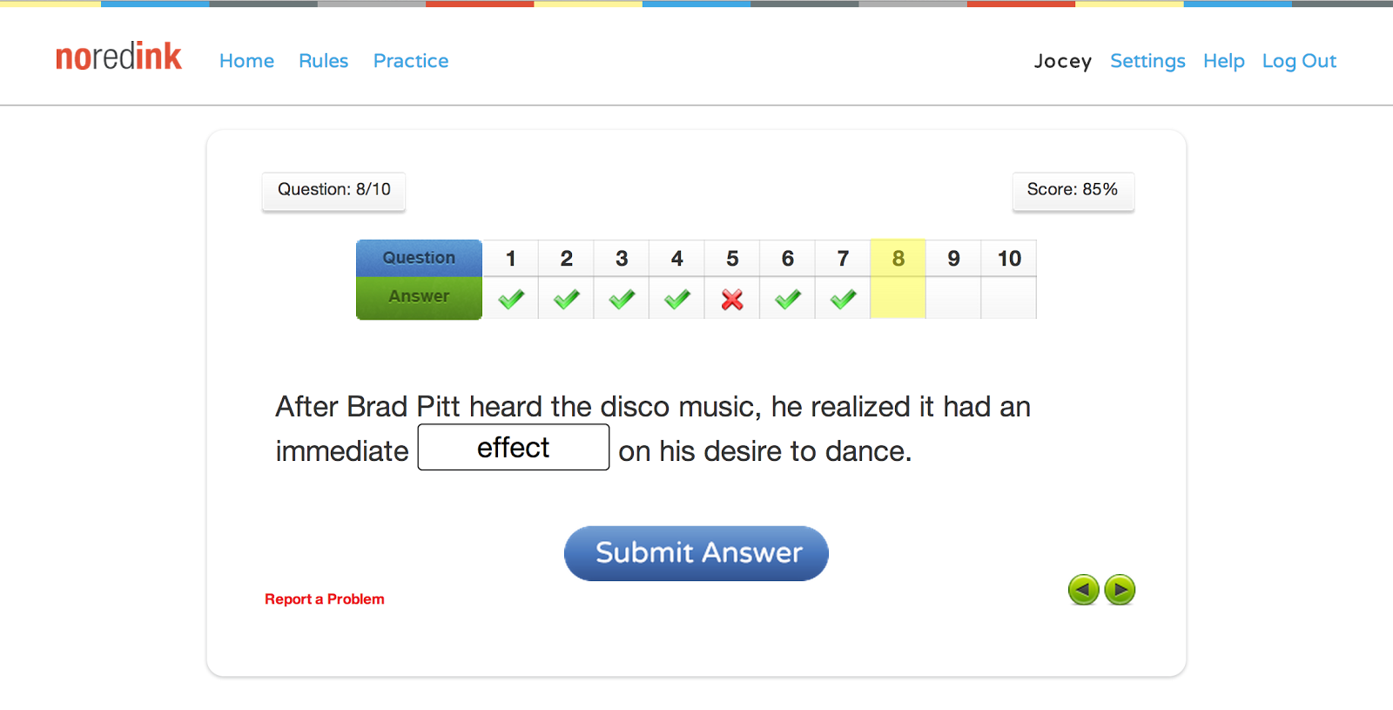

Your child’s account will be connected to my own, so I can track progress on homework, quizzes, and practice exercises. Students can also take charge of their own learning using the color-coded “Mastery Page.” This page shows students how close they are to mastering each topic on the site.

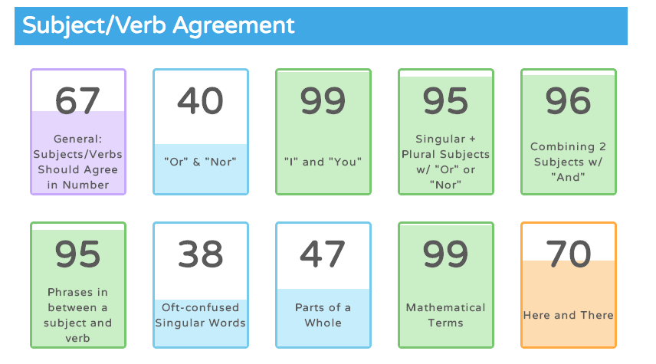

NoRedInk will be a fantastic resource for our young scholars! Please let me know if you have any questions.

Sincerely,
Morgen Hughes

